PAKISTAN REVENUE AUTOMATION (PVT) LTD
TENDER # P-06/2013 DATED 14/03/2013
FOR PURCHASE OF LOW BACK REVOLVING CHAIRS

Ref. Proc-Furniture//2013 March 14, 2013

Subject: TENDER NO. P-06/2013 DATED 14/03/2013 FOR THE PURCHASE OF LOW BACK REVOLVING CHAIRS

Sealed bids are invited from the firms registered with the Sales Tax and Income Tax departments for supply of Low Back Revolving Chairs as per specifications mentioned in Annexure “A”. Terms & Conditions of the Purchase are as below:

1. Income Tax / Withholding Tax will be deducted in accordance with the law. Kindly note that the Sales Tax shall also be deducted in accordance with the law.

2. PRAL reserves the right to increase or decrease the quantity mentioned in the Schedule of Requirement Annexure “A”, accept or reject any bid to be received against this tender inquiry, annul the bidding process and reject all bids at any time prior to award of Contract (s). Justification of the rejection of bid (s) will be provided on request.

3. The delivery of the Chairs mentioned in the Annexure” A” is required on most urgent basis. As such the successful bidder may be in a position to deliver the chairs within one (01) week of the receipt of the purchase order(s) against this Tender Inquiry. Delivery Period must be mentioned clearly.

4. PENALTY:
For failure to comply with the delivery schedule of Contract (s), penalty will be imposed on defaulting Contractor as under:

4.1. 1% of the cost of entire Contract or of such items/job as remain un-supplied/un-completed for every day up to maximum of 5% for 10 days exceeding the job completion/delivery period.

4.2. If the material is not supplied even after payment of penalty for 10 consecutive days PRAL reserves the right to cancel the contract and to get complete the required job/items from elsewhere at risk and cost of the defaulting contractor.

5. The authorized representative of the bidder may quote prices duly stamped and signed.

6. Quoted prices must be inclusive of all taxes (Income Tax and Sales Tax) and duties indicating unit price and total bid price.

7. Price must be quoted including all charges like handling, loading, transportation, unloading of the chairs at PRAL office at Hall # 504, 5th Floor, Evacuee Trust Complex, Agha Khan Road, F-5/1, Islamabad.

8. Quoted price shall be valid for ninety (90) days from the opening date of the bids. However, any subsequent change in taxes and duties as notified by Federal Board of Revenue will be given due consideration.

9. Bidding Form Annexure “B” must also be duly filled in, stamped and signed by authorized representative of the bidder.

10. EARNEST MONEY:
10.1 The Bidder shall furnish as part of his bid, a Call Deposit/Pay Order equivalent to 2% of the total bid value as Earnest Money crossed in favor of "Pakistan Revenue Automation (Pvt.) Ltd.". Bank Guarantee as earnest money shall not be entertained. Any bid not accompanied by Earnest Money shall be rejected without any right of appeal.

10.2 Part earnest money or crossed Cheque / bank guarantee, as earnest money is not acceptable.

10.3 In case of cancellation of contract as default of the Contractor the earnest money shall be forfeited in favor of PRAL.

11. PAYMENT:
Payment will be made as per mutually agreed schedule and in accordance with the terms and conditions spelled out in the contract issued against this tender document.

12. SEALING AND MARKING OF BIDS.
12.1 The bids shall be submitted in sealed envelope marked as under:

MANAGER (PROCUREMENT)
PAKISTAN REVENUE AUTOMATION (Pvt.) LIMITED
HOUSE # 2-A, MAIN EMBASSAY ROAD, SECTOR G-6/4, ISLAMABAD.

12.2 The envelopes shall also bear the word “CONFIDENTIAL” and following identifications:-

BID NO. P-06/2013
FOR SUPPLY OF LOW BACK REVOLVING CHAIRS

12.3 If the envelope is not marked, as instructed above, the PRAL will assume no responsibility for the misplacement or premature opening of the bid.

13. DEADLINE FOR SUBMISSION OF BIDS:
All bids must be delivered in the Office of undersigned on or before the prescribed deadline of 1100 hours on 28/03/2013.

14. LATE PROPOSALS:
Any bid received by the PRAL after the prescribed deadline will be returned unopened to the Bidder.

15. OPENING OF BIDS:
The Purchaser will open the bids in the presence of bidder representatives who choose to attend at 1130 hours on 28/03/2013 at the below mentioned address.

16. Period of warranties for the quoted chairs must be mentioned clearly.

17. If desires by PRAL the lowest bidder(s) will have to provide samples of chairs for approval of PRAL. PRAL shall retain samples till to the final inspection.

18. All bids should include:
18.1 Company’s profile, list of clients with their telephone number and address;
18.2 Copies of Income Tax and Sales Tax registration certificates;
18.3 A call deposit being 2% of the total bid value as Earnest Money crossed in favor of “Pakistan Revenue Automation (Pvt.) Ltd.

(SOHAIL AKHTAR)
Manager (Procurement)
House # 2-A, Main Embassy Road, Sector G-6/4, Islamabad.
Ph: 051-9208687

ANNEXURE-A

SCHEDULE OF REQUIREMENT
TENDER # P-06/2013 DATED 14/03/2013

S.# | Item Description | Qty | Unit Price Including Sales Tax | Total Amount Excluding Sales Tax | Sales Tax on Total Amount | Total Amount Including Sales Tax
1. | LOW BACK REVOLVING CHAIR  Low Back Revolving Chair Imported Structure of Seat & Back made of Ply Wood, upholstery with good quality foam and leatherette, frame made by 16 gauges chromed plated, hydraulic gas lift, tilting machine and chrome base with five caster wheels (as per below given picture) | 150

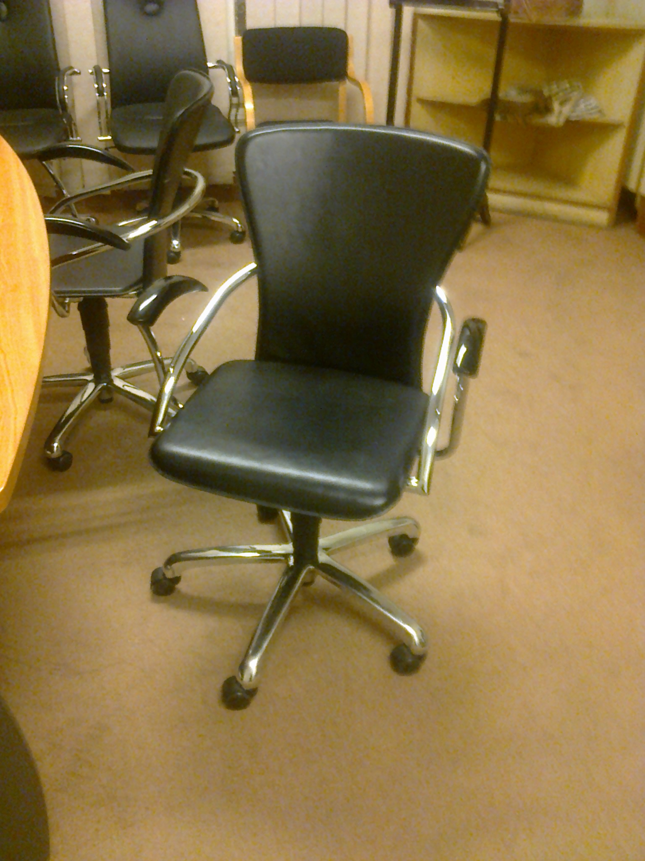

ANNEXURE-"B"
BIDDING FORM

Tender No.P-06/2013, dated 14/03/2013

Pakistan Revenue Automation (Pvt.) Limited, Islamabad.

Gentlemen,

1. Having examined the conditions to Tender and Specifications of Tender No.P-06/2013 dated March 14, 2013 the receipt of which is hereby acknowledged we, the undersigned, offer to install, supply and deliver in conformity with specifications mentioned / given in Annexure “A” and conditions of Tender for the sum of Rs._________________________ (Rupees _____________________________) or such other sums as may be ascertained in accordance with the said Conditions.

2. If our Bid is accepted we shall deliver / commenced the equipment / services mentioned in the tender documents within ______ days from the date of receipt of your firm Purchase Order / Work Order.

3. We agree to abide by the terms and conditions of the Tender for the period of _______ from the date fixed for receiving the same and it shall remain binding upon us and may be accepted at any time before the expiration of that period.

4. Until a formal Purchase order(s) is placed, this Bid, together with your written acceptance thereof, shall constitute a binding contract between us.

5. We understand that you are not bound to accept the lowest or any proposal you may receive or to inform us of the rejection of our bid or to give any reasons therefore.

Dated this ______________________ day of ______________________________ 2013_______________

Signature _______________________ in the capacity of ______________________________ duly authorized to sign Tender for and on behalf of
_____________________________________________________________________________________
(NAME OF FIRM IN BLOCK CAPITALS)
Complete address:________________________________________________________________________

Fax No.____________________________ Telephone No.______________________________________

________________
(SIGNATURE)
Witness:-
1. _______________________

2. -------------------------------------

